**PROJECT FILES - TO SUPPLY LEFTOVER FOOD TO POOR**

|  |  |
| --- | --- |
| Date | 26 June 2025 |
| Team ID | LTVIP2025TMID30678 |
| Project Name | To Supply Leftover Food To Poor |
| College Name | Aditya collage of Engineering and Technology |
| Team members | 1)Sadi ramana (Leader) – 22MH1A04D6   * [Ramanarebel69@gmail.com](mailto:Ramanarebel69@gmail.com)   2)Sravani kasireddy (Documentation developer and opearator ) - 23MHA0412   * [Sravanikasireddy850@gmail.com](mailto:Sravanikasireddy850@gmail.com) |

**CUSTOM SALESFORCE OBJECTS:**

**1.All user**

**2.User - 1**

**3.User - 2**

**4.User - 3**

**CUSTOM OBJECT TABS 1:**

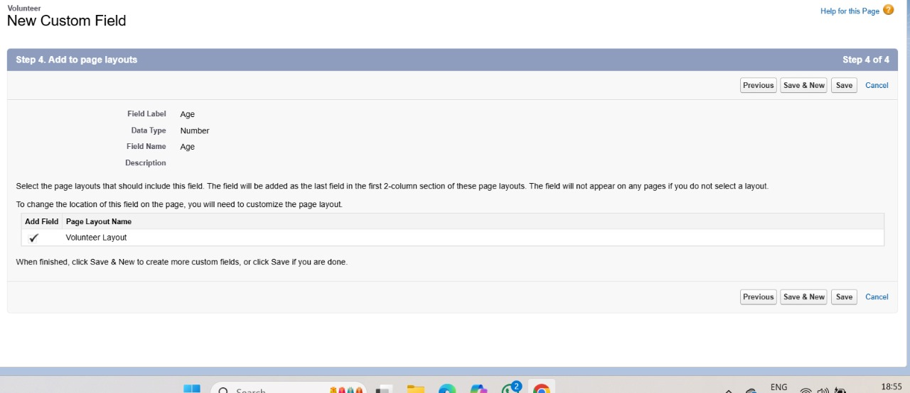

**CUSTOM OBJECT TABS 2:**

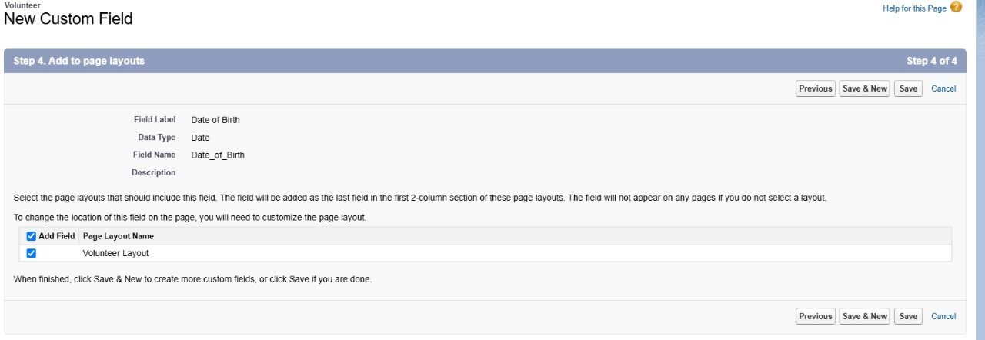

**APEX CODE:**

**Apex Trigger:Drop Off Trigger**

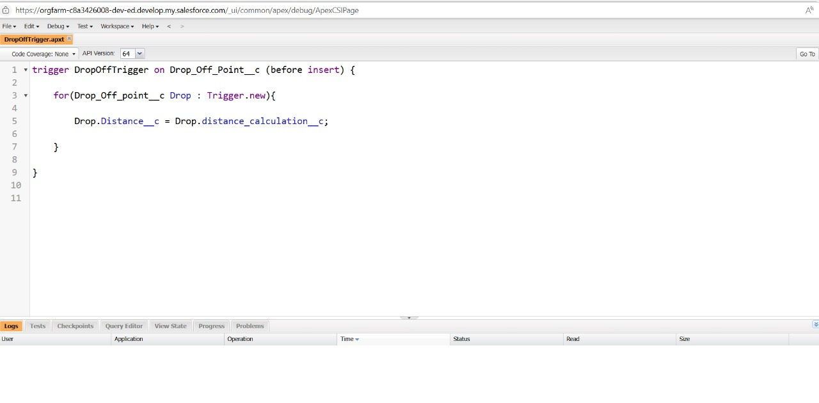

**Permission Sets:**

**“Primary Object” is the custom report**

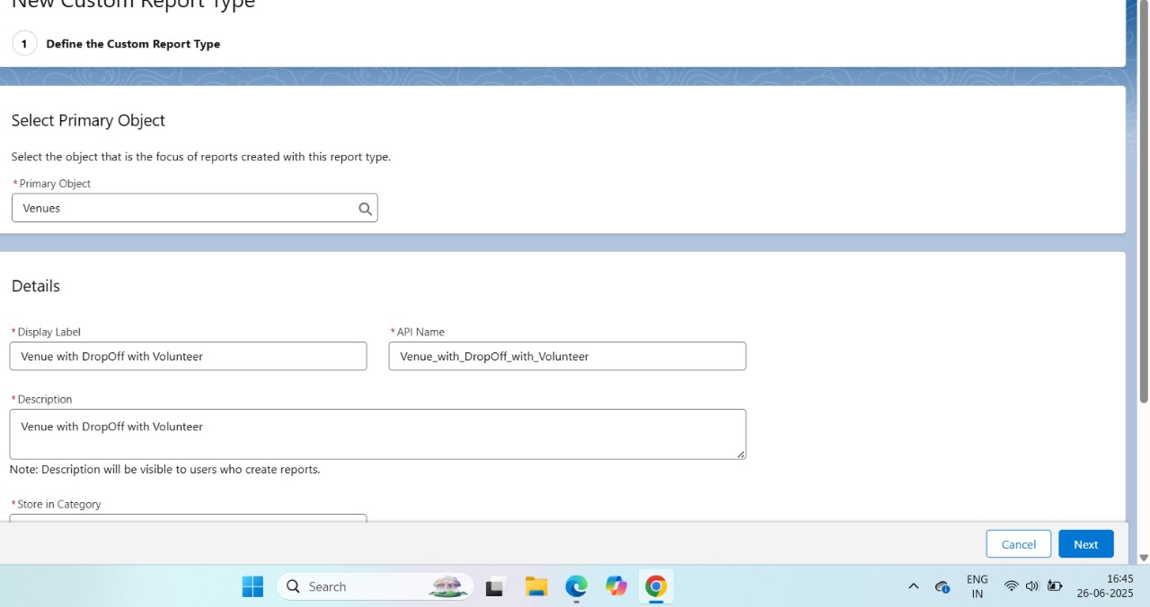

**FLOW:**

**Custom Report:**

